Environmental Policy
SOLP009 – Environmental Policy Statement

SOL Services Ltd provides best-in-class construction, refurbishment, and maintenance solutions for private and public sector clients across the UK & EU.

Our environmental commitments
It is our objective to:
- Minimise the environmental impact of our activities and services, and those of our suppliers and subcontractors through our Business Management System that is compliant with ISO 14001 and other ISO standards.
- Comply with the environmental legislation and other applicable environmental requirements and regularly evaluate our compliance.
- Provide the resources and training to those working on our behalf, to manage procurement and use of materials, waste, and energy management.
- Establish, maintain, and measure ourselves against environmental objectives, to ensure compliance and improvement of business performance.
- Proactively commit to the protection of the environment, by preventing pollution and to minimise the environmental impact, for the life cycle (including disposal) of equipment and any other physical assets under our control.

This policy statement will be reviewed annually to ensure that it remains up to date and reflects our strategic direction.

Andrew Gordge Director
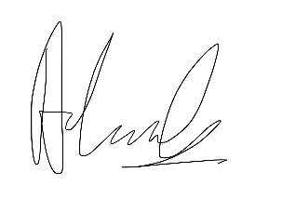
March 2026

