Quality Policy Statement
SOLP017 – Quality Policy Statement
SOL SERVICES Ltd are a Main Contractor who specialise in Project Fit Out, Mechanical & Electrical Installations, Refurbishments, Construction, New Build projects and Minor Works across private, government, public, education, commercial and leisure sectors.
Our quality commitments
It is our objective to:

- Consistently exceed our client’s expectations, while satisfying all applicable requirements (statutory or otherwise).
- Continually improve our services and related processes, including establishing and measuring ourselves against business objectives.
- Use our business management system aligned with ISO 9001 and other ISO standards to optimise our performance and ensure compliance.
- Provide the necessary resources to ensure we fulfil our quality commitments above.
- Make relevant parties aware of this policy, the associated processes and our quality management system.

This policy statement will be reviewed annually to ensure that it remains up to date and reflects our strategic direction.

Andrew Gordge Director
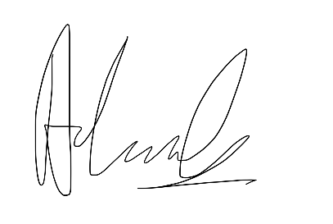
March 2026

